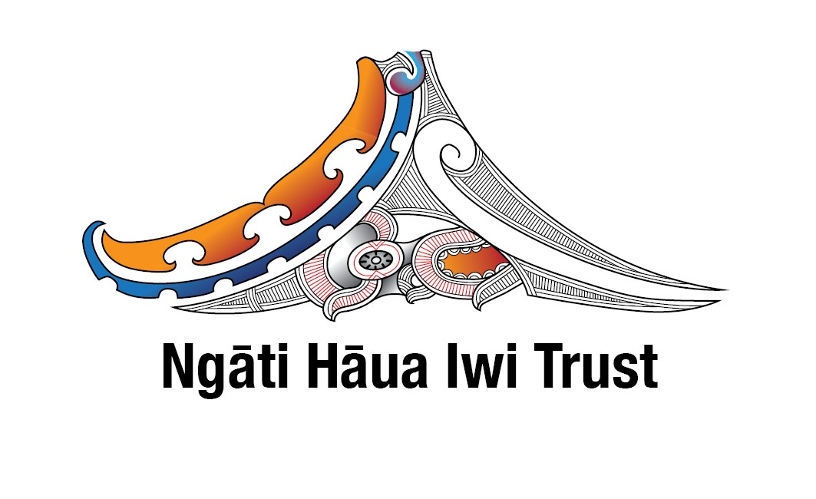
Ngāti Hāua Iwi Trust
Notification of Ngāti Hāua Iwi Trust Mandate Hui

In February 2017, the Ngāti Hāua Iwi Trust submitted a mandate strategy to the Crown for consideration. The mandate strategy proposes that the NHIT seeks a mandate from the Ngāti Hāua claimant community to represent them in Treaty settlement negotiations with the Crown.

The mandate sought is to negotiate all Ngāti Hāua historical Treaty of Waitangi claims whether registered or unregistered that arise from Crown actions and omissions that occurred prior to 21 September 1992, including but not limited to: WAI 764, 1203 and 1299. Further Wai claims to be negotiated also include: Wai 48, 50, 81, 146, 167, 1029, 1097, 1147, 1191, and 1229 in so far as they relate to Ngāti Hāua.

All members of the Ngāti Hāua claimant community over 18 years of age are invited to vote either by a postal vote, an internet vote or by attending and voting at mandate hui on the following resolution, that:

“The Ngāti Hāua Iwi trust is mandated to represent Ngāti Hāua in negotiations with the Crown for the comprehensive settlement of all of the historical Treaty of Waitangi claims of Ngāti Hāua.”

For those who wish to vote, but are not registered on the Ngāti Hāua iwi register, or who wish to vote but do not want to register, you will be able to make a special vote.
The voting period opens 10 March 2017 and closes 21 April 2017. The vote will be administered by Electionz.com.

Mandate hui are as follows:
Date | Venue | Time
10 March 2017 | Novotel Auckland Airport, Auckland | 6.00pm
11 March 2017 | Te Whare Wananga o Aotearoa, Hamilton | 2.30pm
12 March 2017 | Ngapuwaiwaha Marae, Taumarunui | 10.30am
18 March 2017 | Rangahaua Marae, Whanganui | 11.00am
19 March 2017 | Ngā Hau E Wha National Marae, Christchurch | 11.00am

For the purposes of the mandate being sought the Ngāti Hāua claimant community means the collective group of individuals who descend from one or more of the following Ngāti Hāua Ngā Tūpuna/common ancestors and or any of the other Ngāti Hāua hapū recognised ancestors as listed below.

Ngā Tūpuna/common ancestors:
- Paerangi
- Ruatupua Nui
- Hāua

Ngāti Hāua hapū recognised ancestors:
- Te Hoata
- Whakaneke
- Hinengakau and her husband’s Auroa and Tamahina
- Te Rangipuhia
- Hauaroa
- Hekeāwai
- Tū Te Mahurangi
- Te Pikikotuku I

Ngāti Hāua hapū:

- Ngāti Hāua  - Ngāti Hāuaroa  - Ngāti Reremai  - Ngāti Tū  - Ngāti Hekeāwai  - Ngāti Keu* (shared interest)  - Ngāti Kura*  - Ngāti Whati  - Ngāti Te Awhitu  - Ngāti Wera | - Ngāti Hinewai*  - Ngāti Poutama*  - Ngāti Rangitengaue  - Ngāti Tama-o-Ngāti Hāua  - Ngāti Ruru*  - Ngāti Hira  - Ngāti Onga
Copies of the mandate strategy are available on the Office of Treaty Settlements website www.ots.govt.nz, the Te Puni Kōkiri website www.tpk.govt.nz, and also the Ngāti Hāua website www.ngatihaua.iwi.nz. Details about how to make a special vote are also available on the Ngāti Hāua website.

For further information please contact:

Mitch Hall
Project Manager, Ngāti Hāua Iwi Trust
Email – info@ngatihaua.iwi.nz

