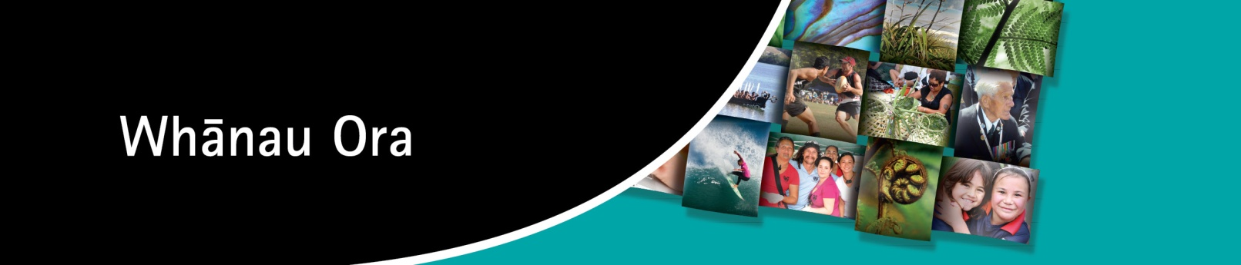

REGIONAL LEADERSHIP GROUPS
Nominations

Introduction

Whānau Ora provides practical, community-based support to whānau so they can be self-managing and determine their own economic, cultural and social development. The primary focus is on achieving best outcomes for whānau through the development of whānau leadership and integrated whānau-centred service delivery.

The Whānau Ora Taskforce Report identified that Whānau Ora will be achieved when whānau are self-managing, living healthy lifestyles, participating fully in te ao Māori, economically secure, actively and successfully involved in wealth creation, and cohesive, resilient and nurturing.

To support the implementation of Whānau Ora, a Governance Group provides strategic advice on policy priorities and ensures co-ordination across government agencies and key stakeholders.

Purpose

Regional Leadership Groups (RLGs) have been identified as a mechanism for providing strong regional direction. Consistent with the Whānau Ora approach and principles, these groups are to be led by and from within the community, with appropriate support from government agencies.

A regional leadership approach aims to capitalise on the vast experience and capacity that exists within whānau, providers and communities. It recognises that meeting whānau needs through whānau-centred service delivery is best led by those who live, experience and participate in this practice on a daily basis.

Roles and Responsibilities

RLGs are to provide recommendations and high quality advice to the Whānau Ora Governance Group, lead strategic change for Whānau Ora within their region, foster excellent communications and relationships, and provide representation of Whānau Ora at the local and regional level.

They will also have an important role in considering funding proposals to support whānau.

Skills and Attributes

Nominations are sought for a candidate who has a primary interest in promoting the wellbeing of whānau within their region. The candidate should be well known in the community and have a sufficient mix of the following skills and experience:

- Experience/expertise in the health, social, economic and cultural sectors.
- Experience in working with whānau collectives and in whānau development at a community level.
- Knowledge of issues facing whānau and service provision to whānau within the region.
- An understanding of local service provision issues and accountability requirements.
- Experience in advocating for and leading change within communities.
- Proven relationship management skills and a wide range of whānau/community networks.
- Knowledge of other initiatives occurring within the region that may impact on, or have synergies with Whānau Ora service provision.

Membership

Membership includes representatives of local agencies including Te Puni Kōkiri, the Ministry of Social Development and District Health Boards, along with community representatives appointed by the Minister for Whānau Ora.

Regions

The 10 regions are based on Te Puni Kōkiri regions:

Te Tai Tokerau (Kaitaia/Whangārei); Tāmaki Makaurau (Auckland); Waikato (Hamilton); Te Moana ā Toi (Whakatāne/Tauranga); Te Arawa (Rotorua); Te Tairāwhiti (Gisborne/Wairoa); Takitimu (Hastings/Featherston); Te Tai Hauāuru (Whanganui/Taranaki/Taumarunui/Palmerston North); Te Whanganui a Tara (Lower Hutt/Blenheim/Levin); and Te Waipounamu (Christchurch/Dunedin/Invercargill).

Nomination Process

Nominees must complete the nomination form and ensure it is received no later than 5.00 pm on Monday 4 June 2012.

Nomination forms that are emailed require nominees to type their name and the date at the bottom of the form.

Completed nomination forms and current curriculum vitae can be e-mailed, faxed or posted to:

Email: kanoa@tpk.govt.nz
Awhina Kanohi, Tāmaki Makaurau (Auckland) Regional Leadership Group Secretariat

Fax: 09 571 2941
Attention: In Confidence, Tāmaki Makaurau (Auckland) Regional Leadership Group
Secretariat

Post: In Confidence
Tāmaki Makaurau (Auckland) Regional Leadership Group Secretariat
c/- Te Puni Kōkiri
Private Bag 92010
AUCKLAND 1142

Terms of Reference for the Regional Leadership Group members is attached.

The successful candidate/s will be notified prior to any community announcement being made.

NOMINATION FORM
Whānau Ora Regional Leadership Groups
Title |  |  |  | First name(s) |  |  |  |  | Surname
Home/postal address |  |  |  |  |  |  | Date of birth
 |  |  |  |  |  |  | Gender
 |  |  |  |  |  |  | Citizenship
Home phone |  |  |  |  |  |  | Please include a current CV with this application
Home facsimile |  |  |  |  |  |  | Date CV prepared
Business address |  |  |  |  |  |  | Information required for statistical purposes only:  If Māori please state your iwi and/or iwi affiliations  Which ethnic group do you belong to?
Business phone
Business facsimile
Mobile phone
Email:

Please indicate in tick box whether nomination is for a Member or Member / Chair position.
Member Position □ Member / Chair position □

Please specify which region this nomination applies to:
Tell us about your knowledge and experience of working with whānau in your region and what attributes you would bring to the Leadership Group.

Summary of Career Experience – (Include a summary of your relevant career experience, specialist skills, areas of expertise including publications, projects, industry and sector experience)
Educational Qualifications
Qualification | Year | Institution

Professional Memberships – Memberships held of professional, industry or sector associations
Government Board Appointments Held (current and previous)
Organisation |  | Year | Role
Private and/or Voluntary Organisation Service/Board Appointments Held (current and previous)
Organisation |  | Year | Role
Is there anything else in your personal history that should be brought to the attention of the Minister Responsible for Whānau Ora, in relation to this nomination. (Please state nil if otherwise)
Referees
Name | Address |  |  | Phone
Conflicts of Interest
Please advise any actual or potential financial, professional or personal conflicts of interest you may have if you are appointed as a member of a Regional Leadership Group e.g. member of a Governance Board, Employee or Financial Shareholder. (please state nil if otherwise)

Privacy Statement
The information provided in this form and any other material provided to Te Puni Kōkiri will be used only to determine the nominee’s suitability for consideration for appointment to a Regional Leadership Group.

Authority And Declaration
This authorises Te Puni Kōkiri and the New Zealand Police to make various enquiries in New Zealand and overseas, to verify or add to the information you have provided or which has been gathered about you, and to obtain information from various organisations such as courts, employers, educational institutions, Government agencies, and your referees in New Zealand and overseas. The provisions of the Criminal Records (Clean Slate) Act 2004 apply to this authorisation.

I hereby authorise the Chief Executive of Te Puni Kōkiri, or the New Zealand Police to make or cause to be made, in New Zealand or elsewhere, whatever enquiries are considered appropriate to verify or add to the information provided by me, or concerning me, and authorise such enquiries to be made before an appointment to a Regional Leadership Group.

I hereby authorise and request all Courts, Police, Service Boards, Employers, Educational Institutions, Banks and other Financial Institutions and all Government Agencies both foreign and domestic, and any other body or person to whom this authority may be presented to allow any accredited representative of Te Puni Kōkiri or of the New Zealand Police to inspect and obtain copies of any or all documents and records relating to me (either solely or jointly with any other person) and to provide that representative with all information relating to me which may be requested in the course of the enquiries described above, for the purpose of determining my suitability to be appointed to a Regional Leadership Group.

I authorise the named referees to disclose information to Te Puni Kōkiri relevant to the consideration of my appointment to a Regional Leadership Group. I understand that the information received by Te Puni Kōkiri is supplied in confidence as evaluative material and will not be disclosed to me.

I have completed all sections of the application form and the information supplied in this application is correct. I understand that providing incorrect, incomplete or misleading information will render this application invalid and may result in the revocation of any appointment made in reliance of such information.

Signature: Enter your name here as a signature Date: Enter the date here__________
(the inclusion of your name in the “signed” area above will be deemed to confirm the above authorisations and declaration)

REGIONAL LEADERSHIP GROUP – TERMS OF REFERENCE

1. Term of Establishment

- Regional Leadership Groups will be established from 16 July 2010 to 30 June 2013.

2. Role and Responsibilities

- Regional Leadership Groups will be responsible for:
- leading strategic change for Whānau Ora within their region;
- providing positive representation of Whānau Ora at the local and regional level;
- fostering excellent communications and relationships within regions;
- ensuring the work of the Group is coordinated with other local and regional initiatives and services;
- providing high quality advice and recommendations to the Governance Group on the selection of Whānau Ora service providers; the development and implementation of Programmes of Action; regional whānau-centred service delivery and initiatives; priority areas and other issues or areas of advice as determined by the Governance Group; and
- monitoring and reporting on results, outcomes, best practice examples/models and implementation issues in their region.

- Each Regional Leadership Group will determine how it will best organise itself to carry out its role and responsibilities. For Regional Leadership Groups in large geographical regions, this may include reviewing how input will be drawn from smaller localities to ensure that regional diversity, whānau needs and local realities.

- The performance of Regional Leadership Groups in carrying out their role will be evaluated annually by the Governance Group and reported to the Minister Responsible for Whānau Ora. Any issues of performance or operation will be managed by the Governance Group.

3. Regional Boundaries

- Regional Leadership Groups will be established across 10 regions based on the current Te Puni Kōkiri regional boundaries, as set out in Appendix 1.

4. Membership

- Regional Leadership Groups will be made up of one representative each from Te Puni Kōkiri, Ministry of Social Development and District Health Boards, along with community representatives appointed by the Minister Responsible for Whānau Ora on the advice of the Governance Group.

- Agencies will confirm their respective members of each Regional Leadership Group by 10 June 2010.

Membership and Representation

- Regional Leadership Groups will have a maximum membership of 10 people. This will include the three government officials and between three to seven community representatives.

Skills and Experience

- Any member appointed to a Regional Leadership Group will be well known in the community and have a sufficient mix of the following skills and experience:

- experience/expertise in the health, social, economic and cultural sectors;
- experience in working with whānau collectives and in whānau development at a community level;
- knowledge of issues facing whānau and service provision to whānau within the region;
- an understanding of local service provision issues and accountability requirements;
- experience in advocating for and leading change within communities;
- proven relationship management skills and a wide range of whānau/community networks;
- knowledge of other initiatives occurring within the region that may impact on, or have synergies with Whānau Ora service provision.

- Members of Regional Leadership Groups will have a primary interest in promoting the well-being of whānau within their region.

Chair and Deputy Chair

- The Chair and Deputy of the Regional Leadership Group will be recommended by the Governance Group and be appointed by the Minister.

- Regional Leadership Groups will be led and managed by a Chair whose role will be to:
  - ensure the effective functioning and integrity of the Group;
  - approve meeting agendas and minutes;
  - chair all meetings and lead discussions and decision making;
  - ensure the Group is well informed to carry out its role;
  - liaise with Te Puni Kōkiri national office and Governance Group Chair as required;
  - act as an official spokesperson for the Regional Leadership Group; and
  - ensure effective relationships and responsive communications are maintained with the Governance Group, providers, iwi, government agencies and key regional stakeholders.

- The Deputy Chair will be responsible for leading and chairing the Regional Leadership Group in the absence of the Chair.

Replacement of members

- The Regional Leadership Group will agree an appropriate process for replacing members in consultation with the Governance Group.

5. Code of Conduct

Conflict of Interest Arrangements

  - Individuals nominated as Regional Leadership Group members will be required to complete a full disclosure of affiliations and conflict of interest, and consent to police check at the time of nomination.

  - Members will be required to immediately disclose to the Group any and all impending or potential conflicts. That member shall absent themselves, without comment from any discussion deliberation and decisions involving other organisations or individuals in which they have a conflict of interest.

  - Members must not use their positions on the Regional Leadership Group to obtain employment or special considerations, or to conduct private business or personal services.

Confidentiality

  - Members will respect the confidentiality appropriate to issues of a sensitive nature.

  - Information received or discussed at meetings shall remain confidential, unless otherwise agree by the Regional Leadership Group or Chair. It cannot be used by members for personal gain or the gain of a family member of associate.

6. Accountability and Reporting

- Regional Leadership Groups will be accountable to the Whānau Ora Governance Group.

- Monthly reports will be provided to the Governance Group in the first year of Whānau Ora implementation and on a quarterly basis in subsequent years. Additional reports may be provided where required, or at the request of the Governance Group.

7. Secretariat

- The regional Te Puni Kōkiri office will provide secretariat services to the Regional Leadership Group. This role will include:
- scheduling and coordinating Regional Leadership Group meetings;
- minuting discussions and key decisions;
- coordinating the development and provision of monthly reports to the Whānau Ora Governance Group on behalf of the Regional Leadership Group;
- liaising with Te Puni Kōkiri national office to:
- coordinate the provision of reports and papers between the Regional Leadership Group and Governance Groups;
- coordinate media releases, media statements and public communications on behalf of the Regional Leadership Group;
- coordinate actions with regional officials and DHB’s in response to Governance Group decisions;
- ensuring papers are provided to Regional Leadership Group members in a timely fashion; and
- administrating payment of community member’s fees and arranging reimbursement of reasonable expenses.

8. Meetings

- The Regional Leadership Groups will meet monthly from 16 July 2010 to 30 June 2011 and quarterly from 1 July 2011 to 30 June 2013. Additional meetings may be organised by the Chair if required.

- To enable an appropriate review of papers and materials, members will be sent information in advance of meetings in either paper form or electronically. Proceedings of all meetings will be minuted, signed by the Chair and approved by the Regional Leadership Group at the subsequent meeting.

- The Chair will establish the agenda for each meeting.

9. Communications and Relationship Management

Engaging with the Whānau Ora Governance Group

- Regional Leadership Groups will provide monthly written reports to the Governance Group. The Chair, or representatives of the Regional Leadership Group may be required to meet with the Governance Group from time to time. These meetings will be coordinated by Te Puni Kōkiri national office, in conjunction with the Governance Group Chair and Regional Leadership Group Chair.

Engaging with regional providers, local authorities, iwi and community organisations

- Regional Leadership Groups will maintain effective relationships with key regional stakeholders to support the successful implementation of Whānau Ora within their region.

Communicating with media

- The Chair of the Whānau Ora Governance Group shall be the media spokesperson on all national and political matters pertaining to Whānau Ora. The Chair of the Regional Leadership Group shall be the media spokesperson on local matters for the group as required. All communications between the Regional Leadership Group and media will be coordinated through Te Puni Kōkiri.

APPENDIX 1: Regional Boundaries

Te Puni Kōkiri Regions
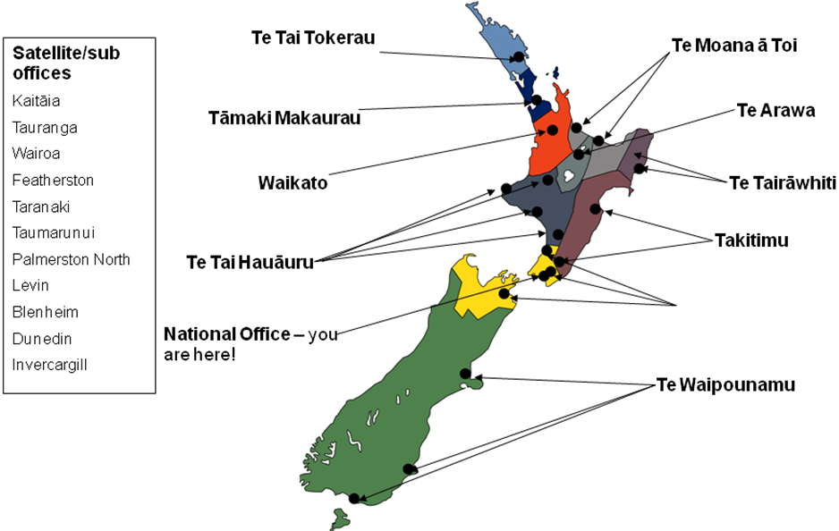

Ministry of Social Development Regions District Health Board Regions

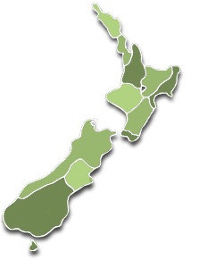
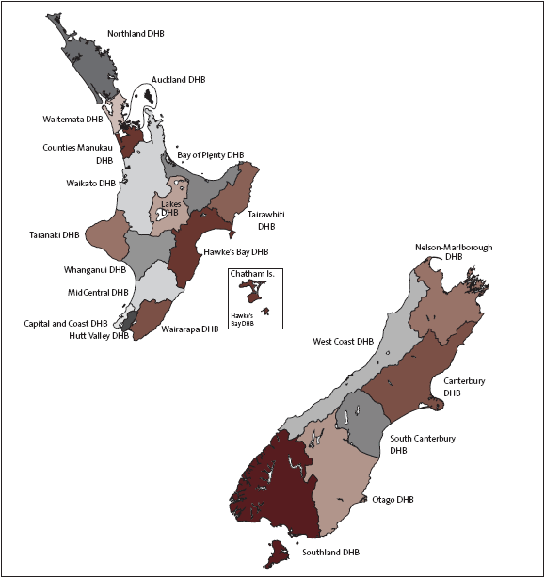

Whānau Ora Region | TPK Coverage | DHB Coverage |  | MSD Coverage
Te Tai Tokerau - from Mangawhai on the east coast to Kaipara Harbour on the west coast and north to the North Cape, marginally north of Cape Reinga. The region covers three districts: Far North, Whangārei and Kaipara. | Te Tai Tokerau Office | Northland DHB |  | Northland region
Tāmaki Makarau - from the South Kaipara in the north to the southern reaches of the Manukau Harbour. | Tāmaki Makarau Office | Waitematā DHB  Auckland DHB  Counties Manukau DHB |  | Auckland region
Waikato - from the Bombay Hills and Port Waikato in the north, along the western coastline south to Mōkau, eastward embracing the King Country, through to the Kaimai Ranges, the Hauraki plains and returning northwards to the Coromandel Peninsula. | Waikato Office | Waikato DHB |  | Waikato region
Te Moana ā Toi - from Athenree in the north, to Lotten Point in the south-East. | Te Moana ā Toi Office | Bay of Plenty DHB |  | Bay of Plenty region
Te Arawa - from Te Awa (near Maketū) to Te Maunu (Papamoa) to Titiraupenga (Pureora-Western Bays, Taupō) to Titi o Kura (the peak at the beginning of Kaweka Range near Te Haroto, Napier/Taupo Highway) and back to Te Awa. | Te Arawa Office |  | Lakes DHB |  | Bay of Plenty region
Te Tairāwhiti - begins north at Potikirua and ends south at the Mōhaka river, running inland to Matawai and down to Tuai at Waikaremoana. | Te Tairāwhiti Office |  | Tairāwhiti DHB |  | Gisborne region
Takitimu – from the Mohaka River in the north to the Wairarapa in the south with the western boundaries formed by the ranges from Te Haroto south to the Tararua and Ruahine ranges. | Takitimu Office |  | Hawkes Bay DHB  Wairarapa DHB  Mid-Central DHB |  | Hawkes Bay region
Te Tai Hauāuru - covers the western side of the lower North Island, extending from the Mohakatino River in the north through to the Manawatū River in the south. | Te Tai Hauāuru Office |  | Taranaki DHB  Whanganui DHB  Mid-Central DHB |  | Taranaki region  Manawatu – Wanganui region
Te Whanganui a Tara – from Turakirae as its southern boundary, extending into the Horowhenua and down through Kapiti and Porirua, crossing over to the Tau Ihu o te waka a Maui. It includes also Rekohu – Wharekauri, the Chatham Islands. | Te Whanganui a Tara Office |  | Mid-Central DHB  Capital Cost DHB  Hutt DHB  Nelson Marlborough DHB |  | Wellington region  Tasman region  Nelson region
Te Waipounamu - from north of Kaikōura on the east coast of the South Island, south to Rakiura (Stewart Island) and up the West Coast to Kahurangi Point. | Te Waipounamu Office |  | West Coast DHB  Canterbury DHB  South Canterbury DHB  Otago DHB  Southland DHB |  | Marlborough region  West Coast region  Canterbury region  Otago region  Southland region

