Mandating Information

Prepared by the Ngāti Kahungunu ki Wairarapa-Tāmaki Nui ā Rua Trust

Kāore i kotahi te whakahaere o ngā tikanga ā iwi
He iwi āno me ōna tohunga me ōna tikanga me āna whakahaere
Hiki atu he iwi, pērā tonu. Nō reira, kia mau koe ki ōu ake.
Mā ō rātau uri e mau ō rātau nā kōrero.
Engari kia mau koe ki ngā kōrero a mātua, ā ōu tūpuna.
Inā ka tika, ka waiho mai ētahi mātauranga hei taonga mōu.
Translation
There was no one universal system of teaching in the Whare-wananga
Each tribe had its own priests, its own colleges, and its own methods
From tribe to tribe this was so. My word to you is: “Hold steadfastly to our teaching
Let their descendants adhere to their teaching, and you to yours
So that if you err, it was we who declared it unto you, and if you are right, it was we who shall leave to you these valuable taonga.
[Te Whatahoro Jury, 1865]

E mihi kau atu ana ki tō tātau kaipāruauru o te one whakarito, nāna i hanga te rangi me te whenua. Ki a rātau mā kua tīokaokahia ake nei e rātau te whārangi rau pūangiangi, whakangaro atu rā ki ngā nohoanga matamata a rātau mā, ngā kanohi te urunga o te rā kua ngaro, kua ngaro i te rā nei. Haea te kākahu whakaruru, paea ki tua ki Paerau.
“We pay our respects to those who have passed on.”
Kāti, e kore e tawhiti te whakaaro ki ngā tūpuna kua whetūrangitia. Kua huakina mai i konei te mata nui a Kahungunu me ōna tūpuna, ōna marae, ōna papakāinga, onā māra mahinga kai, ōna pae maunga, ōna moana, ōna roto, ōna awa, whānau hoki, mai i te Wairarapa ki Tāmaki Nui ā Rua.
“Our thoughts be with our tūpuna who sought excellence for their uri throughout time, and today the face of Kahungunu uri from Wairarapa to Tāmaki-nui-ā-Rua with all its ancestral marae, mountains, river ways, lakes, food gardens, hapū and papakāinga pay deep homage.

Introduction

- The Crown has agreed to a Mandate Strategy prepared and submitted by the Trustees of the Ngāti Kahungunu ki Wairarapa-Tāmaki Nui ā Rua Trust (“the Trustees” and “the Trust”) for the Trustees holding office from time to time to be the mandated representatives to negotiate the settlement of all the Ngāti Kahungunu ki Wairarapa-Tāmaki Nui ā Rua historical Treaty claims.

- As part of the Mandate Strategy, the Trustees agreed to provide all interested parties with certain information outlined in the Mandate Strategy in order to address overlapping claim issues and to provide information to iwi members ahead of the formal mandate hui.

Ngāti Kahungunu ki Wairarapa-Tāmaki Nui ā Rua Trust

- Following a lengthy period of consultation within the claimant community the Ngāti Kahungunu ki Wairarapa-Tāmaki Nui ā Rua Trust was established for the purpose of representing the Ngāti Kahungunu ki Wairarapa-Tāmaki Nui ā Rua claimants in historical Treaty claim settlement negotiations with the Crown.

- There are ten trustees elected on the basis of Hapū Karanga. The elections for the Establishment Trustees were organised by each of the Hapū Karanga and took place between 11 and 19 December 2010. The following people were elected:

Ākura: Hone Oneroa;

Tāmakinui-ā-Rua: Kahu Pene and Hayden Hape;

Te Oreore Marae: Pani Himona;

Hurunui-o-Rangi Marae: Ron Mark;

Pāpāwai Marae: Marama Tuuta;

Te Hika o Pāpāuma: Robin Potangaroa;

Ngāi Tumapūhia-a-Rangi: Ian Perry;

Wairarapa Moana: Kingi Smiler; and

Ngāti Hinewaka: Haami Te Whaiti.

- The Trustees intend to build on the mandate they received through their election by seeking to become the mandated representatives of the Ngāti Kahungunu ki Wairarapa- Tāmaki Nui ā Rua claimants through the implementation of the process set out in the Mandate Strategy.

The Claimant Definition

- The Ngāti Kahungunu ki Wairarapa- Tāmaki Nui ā Rua claimants include the members of the hapū listed in the table below who have exercised or descend from those who have exercised customary rights within the area set out in the map on page. Further hapū may be added as further research is undertaken.

Ngāti Ahuahu | Ngāti Hikarara | Ngāti Moe | Ngāti Te Aokino
 | Ngāti Hikawera | Ngāti Muretu | Ngāti Te Hau
 | Ngāti Te Hina | Ngāti Mutuahi
Mere Te Huinga | Ngāti Ruawahine | Ngāti Ngapuoterangi | Ngāti Kawekairangi
Ngāti Matangiuru | Ngāti Hinepare | Ngāti Pakapaka | Ngāti Te Korou
 | Ngāti Hineraumoa | Ngāti Hinetauira | Ngāti Matangihia
Ngāti Te Wheke | Ngāti Pakuia | Ngāti Parera | Ngāi Tukoko
Ngāi Tahu-Makakanui | Ngāti Matehou | Ngāti Rakaipaaka | Ngāti Kahukuranui
Ngāti Hinewaka | Ngāti Hopara |  | Ngāti Tumanuhiri
Ngāi Taneroa | Ngāti Ira | Ngāti Punarewa
Ngāti Puta | Ngāti Tukaihara | Ngāti Pohoi | Ngāti Turanga
Ngāi Te Hangarakau | Ngāti Kahukuraawhitia | Ngāti Rakairangi | Ngāti Rakaiwhakairi
Ngāti Te Rangitāwhanga | Ngāti Kaiparuparu | Ngāti Rangaranga | Ngāti Whatangarerewa
Ngāi Te Ao | Ngāti Kaihuitu | Ngāti Tutemiha | Ngāti Noti
Ngāti Rangitehewa | Ngāti Rongomaiaia | Ngāti Te Rangikoianake | Ngāti Te Whātuiāpiti
Ngāti Kaitahi | Ngāti Kakawa
Ngāti Rua | Ngāti Kauhi | Ngāti Maahu | Ngāti Tahuahi
Ngāti Tahitokoru | Ngāti Kaumoana | Ngāti Rautangata | Ngāti Te Hauaitu
Ngāi Tuohungia | Ngāti Koura | Ngāti Tauiao | Ngāti Hinemanu
Ngāti Hikarahui | Ngāti Maru | Ngāti Tapatu | Ngāti Tu Manawa
Ngāti Hāmua | Ngāti Raekaumoana | Ngāti Waipuhoro | Ngāti Upokoiri
Ngāti Puha | Ngāti Kirikohatu | Ngāi Te Aomataura | Ngāti Te Whakamana
Ngāi te Rangiakau | Ngāti Komuka | Tu mai te Uru | Ngāti Hakeke
Ngāti Parakiore | Ngāti Rakaihikuroa | Ngāi Tamahau | Ngāti Tutohengarangi
Ngāti Hinaariki | Ngāti Te Tohinga | Ngāti Meroiti | Ngāti Pa Te Ika
Ngāti Tangatakau | Ngāti Te Riponga | Ngāti Rangiwhakaewa | Ngāti Te Ruinga
Ngāti Ihaka Rautahi | Te Hika O Pāpāuma | Ngāti Tu | Ngāti Kere
Ngāti Taitama | Ngāti Te Hoori | Ngāti Te Opekai | Ngāti Te Hukairangi
Ngāti Koro | Ngāti Hinerarau | Ngāi Tumapūhia-a-Rangi | Ngāti Tutawake
Ngāi Tunuiarangi | Ngāti Ruawahia | Ngāti Te Umuiti | Ngāti Komuka
Ngāti Takoto | Ngāti Kaiwahie | Ngāti Te Rore | Ngāti Raukau
Ngāti Hineararangi | Ngāti Te Kari | Ngāti Raetea | Ngāti Tuhakeke

- The following marae and papakainga are associated with the claimant group:

Ākura Marae | Hau Ariki Marae | Pouākani Marae | Te Unuunu Marae
Aotea Marae | Mirinoa Marae | Pukaroro marae | Turanganui Marae
Hiona Marae | Tahoraiti Marae | Waihora Marae | Waipoapoa Marae
Mangaakuta Marae | Te Rangimarie Nukutaimemeha Marae | Ngāi Tumapūhia-a-Rangi | Parekarangaranga Marae
Hurunuiorangi Marae | Te Aroha o Aohanga Marae | Te Ahu a Turanga Marae | Whakatomotomo Marae
Kaikokirikiri Marae | Te Kohanga Whakawhitiwhiti | Nukutaurua Marae | Te Poho o Te Rangihirawea
Kehemene Marae | Okautete Marae | Ohio Marae | Matira Rangiwhakaoma Marae
Kaitoke Marae | Otaraia Marae |  | Kaihoata Marae
Kaiwaiwai Marae | Pāpāuma Marae | Pāpāwai Marae | Waitapu Marae
Raukumara Marae | Whakaoriori Marae | Te Poho o Hinepare | Te Poho o Tutawake
Kohunui Marae | Whiti-Te-Ra Marae | Takitimu Marae | Te Ore Ore Marae
Motuwairaka Marae | Te Takurua Marae | Te Rae o Rakaiwhakairi | Maunga

The Area of Interest

- A narrative description of the Ngāti Kahungunu ki Wairarapa- Tāmaki Nui ā Rua area of interest is set out below and a map which gives a graphic description is on page 7.

Akura

- Te Rongomahina mau ana ki Mangatakoto mau ana ki Whakarongorongo mau ana ki te awa o Tutahuna ki Piripiri ki Mamaukarua, mau ana ki Waipoua ki Piripiri ki Ruapautihi mau ana ki Kaitamarote ki Mahikiekie ki te ngutu o Mangatakoto mau ana ki Te Papa o te Kohatu ki Te Huru o te Koromiko ki Marapu ki Kapupo ki te Manga a Te Wakarihi ki te Awa o Tawhiti Waingawa mau ana ki roto ki Waipoua ki te rohe Pihopa o Aotearoa [Rongo Parahirahi] mau ana ki Wharerua ki te rua o Takiwhenua mau ana ki Mopuna ki te rohe o Akura ki Waingawa ka whati i runga i te rohe o Wiremu Kingi i araitia te rohe o Te Manihera mau ana ki Rangitakaiwaho me Piripiri ka hoki ki Rongomahina.

Tāmaki Nui-ā-Rua

- Beginning at Poroporo on the coast about 5kms north of Cape Turnagain, the line follows the coast southwards about 38kms to the Mataikona River mouth, it then follows the Mataikona River and its tributaries, the Pakowhai River and Makoura Stream to Dreyers Rock continuing eastward just north of Mauriceville to Mount Dundas, a trig point on the Tararua Ranges. Travelling north along the central line on the Tararua Ranges to the Manawatu Gorge where the boundary briefly enters and follows the gorge westward slightly to the peaks of the Ruahines then follows the central line of the Ruahine Ranges to Maharahara Trig point then northwards to the northern boundary of the old Manawatu No. 5 [Ngamoko] land block, turning eastward travelling and including Manawatu No. 6 [Tuatua] block, Manawatu No 8 [Wharawhara] block, most of the Ngapaeruru block, Tautane block to the beginning point at Poroporo.

Te Ore ore Marae

- Commencing at the Mataikona Block and following the Aohanga River inland to the Waingongoro Stream then north to the Makatote Stream to the Mataikona River inland to Pakowhai River then north along the Puketoi Ranges to Mangatainoka then south to Eketahuna. From this point we head west to Pukemoremore then south along the Tararua Ranges to Mount Alpha, east towards and along the Waiohine River then north along the Taratahi/Hikawera block to the Waingawa River. The line then proceeds south to the Taueru Junction then east across the Maungaraki Ranges to Kaiwhata and north along the coast back to Aohanga.

Hurunui-o-Rangi Marae

- Mataikona River inland to the Pakowhai River then north along the Puketoi Ranges to Mangatainoka then south to Eketahuna then west towards Pukemoremore then south along the Tararua Ranges to Mount Alpha then following the headwaters of the Waiohine River east then north along the Taratahi/Hikawera block to Waingawa East to converge with the Ruamahanga then south to Huangarua River across to Maungaraki to Pahaoa then along the coast line to Mataikona the starting point.

Pāpāwai Marae

- From the mouth of the Orongorongo east along the southern coast to Whangaimoana. Inland to Ruakokoputuna turning to the east and the mouth of the Awhea. North along the coast to Uruti then inland to Maungaraki then Rangitumau. North again to Pukaha then on to Arete. Heading south along the Tararua and Remutaka Ranges to the mouth of the Orongorongo.

Te Hika O Pāpāuma

- In former times the hapū boundaries were known as the Castlepoint Purchase Block. It extended from the north at Akitio/Cape Turnagain along the coast line down towards Whareama there by following the river inland to Taueru, from Taueru inland through the mountain range, Maungaraki to the Puketoi Range and from Pongaroa back out to Akitio/Cape Turnagain.

Ngāi Tumapūhia-ā-Rangi

- This claim covers the traditional rohe of Ngāi Tumapūhia ā Rangi, which is located on the Eastern shores of the district of Wairarapa and extends inland to the Maungaraki Range and South to the Awhea River.

- “Mai i Whareama ki Taueru, whiti atu ki te Taumata o te Hangatu, ahu atu ki te Karaka o Waimatua ki Wainuioru, ahu atu ki te Karaka o Waimatua ki Te Awhea rere atu ki Hawerawera ki te ngutu awa o Te Awhea, rere atu ma te takutai ki Whareama.”

Wairarapa Moana

- Wairarapa Lakes including Wairarapa Moana, Onoke Moana and the Ruamahanga River connecting both lakes, to the spit between Okorewa and Kiriwai and all surrounding lands covered by the traditional flood-line pre the 1855 earthquake.

Ngāti Hinewaka

- Ngāti Hinewaka are a coastal people. Their lands extend from Lake Onoke in the South along the south Wairarapa Coast, around Matakitaki-akupe, up the East Coast through the area around Te Unuunu (Flat Point), inland towards Kehemane (Tablelands), and back towards the Ruamahanga River and down the river to Onoke. Ngāti Hinewaka’s rohe embraces significant amounts of coastal land and land with high cultural, historical and archaeological value.

Map of Area of Interest

- A map setting out the Ngāti Kahungunu ki Wairarapa- Tāmaki Nui ā Rua area of interest for the purposes of negotiations with the Crown for the settlement of the Ngāti Kahungunu ki Wairarapa- Tāmaki Nui ā Rua historical Treaty claims is on the following page.
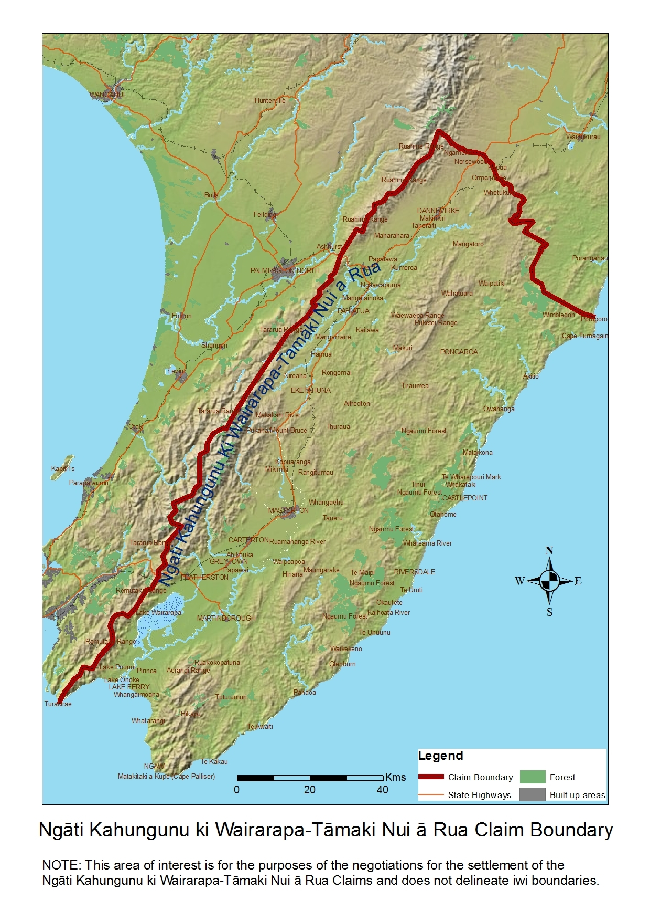

Claims to be negotiated

- The claims to be settled (to the extent that they are relevant) are set out in the table below.

Claim no | Short title | Named claimant/s
Wai 85 | Wairarapa Moana Pouakani Incorporation | Kingi Smiler
Wai 97 | Wairarapa Moana Trust | Hinepatokariki Paewai (deceased) and Niniwa Munro.
Wai 171 | Land Interests of Henare Matua | Henare Matua Kani
Wai 429 | Ngāi Tumapūhia-a-Rangi | Ryshell Griggs
Wai 652 | Ngati Kahungunu ki Tāmaki-nui-ā-Rua | Josephine Hape[deceased]
Wai 741 | Local government, Department of Conservation, and taonga protection claim | Murray Hemi
Wai 744 | Wairarapa 5 Percents claim | Bernard Patrick Manaena (deceased)
Wai 939 | Te Hika-o-Pāpāuma o Wairarapa ki Kahungunu | Matai Broughton and Takare Leach.
Wai 943 | Ratima whānau claim | Lance Ratima
Wai 944 | Hurunui-o-Rangi Marae claim | Frances Reiri-Smith and Henare Manaena.
Wai 959 | Ngati Hinewaka | Memory Te Whaiti (deceased), now Haami Te Whaiti
Wai 962 | Jury whānau lands claim | Rebecca Harper
Wai 1008 | Anaru whānau claim | Kerylee Jan Anaru
Wai 1019 | The Wairarapa Rohe Crown Consultation claim | Murray Hemi & others
Wai 1021 | Ngati Whātuiāpiti land reserves claim | Claude Pene
Wai 1022 | Pāpāwai Marae Committee claim | Jim Hemi [deceased], Amelia Jaro [deceased], and Kingi Matthews.
Wai 1023 | The Pouākani Wairarapa Exchange claim | Noelene Reti
Wai 1049 | Descendants of Taueru claim | Charmaine Kawana
Wai 1050 | Ngā Aikiha claim | Dorothy Chown & others
Wai 1057 | Akura Marae, Ngati Hāmua, Ngati Ahuahu claim | Manu Te Whata and Michael Allen junior.
Wai 2241 | Nga Uri o Te hau | Manu Te Whata, Hone Oneroa, Rawiri Smith
Wai 1453 | Land interests of Ngati Ngarengare | Janine Anne Smith-laea
Wai 1569 | Native Land Court and succession laws. | Tina Harawira, Jackie Rongonui, Cherry Ngatai
Wai 2211 | Wairarapa Moana & land issues | Leonard Tami Te Hiko Thompson, Olivia Horiwia Tamihana.
Wai 2213 | Coastal resources | Jenny Winipere Mauger and Jim Hutcheson
Wai 2225 | Heritage Management, Crown Purchases & Native Land Court. | Kaea Aotea Matiaha Te Arohatai Te Rangipuataata
Wai 2269 | Land issues. | Rex Murray Hemi

- Also included in the mandate are any historical claims of Ngāti Kahungunu ki Wairarapa-Tāmaki Nui ā Rua which have not yet been registered with the Waitangi Tribunal, including claims of individuals or whānau.

- The Trustees seek the mandate to settle all historical Treaty of Waitangi claims of Ngāti Kahungunu ki Wairarapa-Tāmaki Nui ā Rua, whether they are registered or unregistered.

- The Trustees are committed to addressing any reasonable enquiries that individuals and/or groups may have about the Trust’s mandating process and any information provided in this document.

- Individuals and/or groups may also wish to liaise directly with the Crown in regards to their concerns or any questions they may have.

Timeframes

- The Trustees intend to carry out the formal mandating process in late January to February 2012 with a series of eleven hui across the country. The Trustees encourage all members of Ngāti Kahungunu ki Wairarapa-Tāmaki Nui ā Rua as defined in the claimant definition above to attend the hui. Closer to the mandate hui, advertisements will be placed in national and local newspapers. Information will also be circulated through iwi panui, on Radio Kahungunu and other appropriate medium.

- At these mandating hui, the Trustees will not only be seeking a formal mandate from the iwi members, but will also be providing important information about the Trust and the settlement negotiation process in general.

Contact Details for Ngati Kahungunu ki Wairarapa-Tāmaki Nui ā Rua Trust

- All correspondence and enquiries can be made to:

Robin Paratene
Project Manager
Phone: 021 762 460
Email: robin@rpconsulting.co.nz

or

Diane Rewi
Secretary of the Trust
18 Rimu Street,
Lansdowne,
Masterton 5810.
Phone: (06) 378 2102
Email: rewi@xtra.co.nz

Crown Contact Details

- Office of Treaty Settlements
All correspondence and enquiries can be made to:

Phone: (04) 494 9800
Email: KKWTNR.Feedback@justice.govt.nz

- Te Puni Kōkiri
All correspondence and enquiries to be made to:

Lucy Te Moana / Amelia Dalley
Te Puni Kōkiri House
143 Lambton Quay
Wellington 6011
Phone: (04) 819 6000
Email: temol@tpk.govt.nz
dalla@tpk.govt.nz

